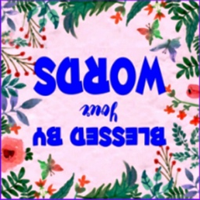
Legacy Starter Sheet
A gift of memory. A bridge across generations.
From the heart of Blessed By Your Words
- What is something your parents or grandparents taught you that you still live by today?

- Can you tell me about a time in your life when God felt especially close to you?

- What is one mistake you made that taught you a valuable life lesson?

- What are you most proud of — not what you did, but who you became?

- What do you want future generations of our family to always remember or do?

- Was there a dream you had for your life that you’re still holding onto — or had to let go?

- What do you hope people will say about you 50 years from now?
- If you could give one blessing or piece of advice to every child born in our family, what would it be?

- What are your favorite traditions, foods, or sayings that make our family unique?

- How did your faith help you through the hardest times in your life?

❤■ Bonus: “If I could wrap one piece of my heart i a box and give it to you, it would be...”

Hope this blesses you, Rev. Sunae www. Blessedbyyourwords.com. 914-229-9221

